

Department of Computer Science

Lab Manual

SE 221-L Computer Organization and Assembly Language

Instructor’s Name: Sir Syed Muhammad Daniyal
Student’s Name: Sarmad Ali
Roll No.: 69617 Batch: Mon 8:30 to 11:30
Semester: 3rd Year: 2025
Department: BS Artificial Intelligence

Department of Computer Science

Lab Manual

SE 221-L Computer Organization and Assembly Language

Prepared By:

Usama Amjad

Reviewed / Approved By:
Ilyas younus
Faculty of Engineering Sciences & Technology
Iqra University

CONTENTS
Lab. No. | Date | List of Experiment | Total Marks | Signature | Page #
1. |  | Installing Assembly Language Software (NASM) and getting familiar with its features and operations.
2. |  | To perform Addition, Subtraction between two numbers using NASM simulator.
3. |  | To perform Multiplication and Division of two numbers using NASM simulator.
4. |  | To perform calculations using loops in NASM simulator
5. |  | To study the theory of Flag Registers and some of its types.
6. |  | Perform addition and multiplication of two numbers by getting values from user using MIPS simulator.
7. |  | To store multiple values in an Array using MIPS simulator.
8. |  | Open-ended Lab 1 | 10
 |  | Mid Term Examination | 25
9. |  | To perform operations on Floating Points and Double Values using MIPS simulator.
10. |  | To perform comparison between numbers and floats using MIPS simulator.
11. |  | Using while loop in MIPS simulator.
12. |  | Calculating Factorial of a number given by user using MIPS simulator.
13. |  | Calculating Average of numbers using MIPS simulator.
14. |  | Implement if Statement using Branch
15. |  | Open-Ended lab 2 | 10
16. |  | Open Ended Lab Assesment
 |  | Final Examination | 40

Psychomotor Rubrics for Software based Lab
Course Name (Course Code): ___________________________________________________________

Semester: ___________________________________________________________

Criteria | Exceeds Expectations (>=90%) | Meets Expectations (70%-89%) | Developing (50%-69%) | Unsatisfactory (<50%)
Software Skills | Ability to use software with its standard and advanced features without assistance | Ability to use software with its standard and  advanced features with minimal assistance | Ability to use software with its  standard features with assistance | Unable to use the software
Programming  / Simulation | Ability to program/ simulate the lab tasks with simplification | Ability to program/ simulate the lab tasks without errors | Ability to program/ simulate lab tasks with errors | Unable to program/simulat  e
Results | Ability to achieve all the desired results with alternate ways | Ability to achieve all the desired results | Ability to achieve most of the  desired results with errors | Unable to achieve the desired results
Laboratory Manual | All sections of the report are very well written and technically accurate. | All sections of the report are technically accurate. | Few sections of the report contain technical errors. | All sections of the report  contain multiple technical errors.

Psychomotor Rubrics Assessment Software based Lab
Course Name (Course Code): ________________________________________________________

Semester: _________________________________________________________
Lab # | Score Allocation
 | Software Skills Marks (3) | Programming/  Simulation  Marks (2) | Experimental Results Marks (3) |  | Laboratory Manual Marks (2) | Total Marks (3)
1
2
3
4
5
6
7
8
9
10
11
12
13
14
Total Marks |  | 140 |  | Total Obtained marks

Overall Score: ___________out of 10 Examined by: ___________________________
(Obtained Score / 140) x 14 (Name and Signature of lab instructor)

Affective Domain Rubrics Assessment

Course Name (Course Code): ________________________________________________________

Semester: _________________________________________________________
CATEGORY | Excellent (100% - 85%) | Good (84% - 75%) | Fair (74% - 60%) | Poor (Less than 60%)
Speaks Clearly | Speaks clearly and distinctly all the time, and confidently. | Speaks clearly and distinctly most of the  time, but is confused for a brief period of time, however, recovers. | Speaks clearly and distinctly most of the  time, but seems not confident about what has been delivered. Shows lack of confidence. | Often mumbles or cannot be understood and clearly lacks  confidence in delivering  the content
Points:
Preparedness | Student is completely prepared and has obviously rehearsed. | Student seems pretty prepared but might have needed a couple more rehearsals. | The student is somewhat prepared, but it is clear that rehearsal was lacking. | Student does not seem at all prepared to present.
Points
Answer back | Student calmly listens to the questions and responds  to the question confidently  and correctly | Student calmly listens to the questions, responds  confidently but some of the responses are incorrect. | Student shows anxiety while listening to the  questions, and gives some correct responses, but  some of the responses are incorrect. | Student shows anxiety while listening to the  questions, and most of the responses are incorrect.
Points:
Posture, Eye  Contact &  Speaking Volume | Stands up straight, looks relaxed and confident.  Establishes eye contact with everyone in the room during the presentation.  Volume is loud enough to be heard by all members in  the audience throughout the presentation. | Stands up straight and establishes eye contact  with everyone in the room during the presentation.  Volume is loud enough to be heard by the audience, but is sometimes not audible. | Sometimes stands up straight and establishes  eye contact. Volume is loud enough to be heard  by the audience, but many sentences spoken are not clear. | Lazy and informal posture. Does not look at people during the  presentation. Volume is also too soft to be heard by the audience.
Points:

Overall Score: ___________out of 10 Examined by: ___________________________
(Name and Signature of lab instructor)

Open Ended Lab Assessment Rubrics
Course Name (Course Code): ________________________________________________________

Semester: ________________________________________________________

Criteria and Scales
Excellent (10-8) | Good  (7-5) | Average (4-2) | Poor (1-0)
Criterion 1: Understanding the Problem: How well the problem statement is understood by the student
Understands the problem clearly and clearly identifies the underlying issues. | Adequately understands the problem and identifies the underlying issues. | Inadequately defines the problem and identifies the underlying issues. | Fails to define the problem adequately and does not identify the underlying issues.
Criterion 2: Research: The amount of research that is used in solving the problem
Contains all the information needed for solving the problem | Good research, leading to a successful solution | Mediocre research which may or may not lead to an adequate solution | No apparent research
Criterion 3: Class Diagram: The completeness of the class diagram
Class diagram with  complete notations | Class diagram with  incomplete notations | Class diagram with improper naming  convention and notations | No Class diagram
Criterion 4: Code: How complete and accurate the code is along with the assumptions
Complete Code according to the class diagram of the given case with clear assumptions | Incomplete Code according to the class diagram of the given case with clear  assumptions | Incomplete Code according to the class diagram of the given case with unclear assumptions | Wrong code and naming  conventions
Criterion 5: Report: How thorough and well organized is the solution
All the necessary information clearly organized for easy use in solving the problem | Good information organized well that could lead to a good solution | Mediocre information which may or may not lead  to a solution | No report provided

Open Ended Lab Assessment Rubrics
Course Name (Course Code): ________________________________________________________

Semester: ________________________________________________________

Criteria and Scales
Excellent (10-8) | Good  (7-5) | Average (4-2) | Poor (1-0) | Total Marks 10
Criterion 1: Understanding the Problem: How well the problem statement is understood by the student
(10-8) | (7-5)% | (4-2)% | (1-0)%
Criterion 2: Research: The amount of research that is used in solving the problem
(10-8) | (7-5)% | (4-2)% | (1-0)%
Criterion 3: Class Diagram: The completeness of the class diagram
(10-8) | (7-5)% | (4-2)% | (1-0)%
Criterion 4: Code: How complete and accurate the code is along with the assumptions
(10-8) | (7-5)% | (4-2)% | (1-0)%
Criterion 5: Report: How thorough and well organized is the solution
(10-8) (7-5)% (4-2)% (1-0)%
Total |  |  |  | (____/10)

Total marks obtained: ____________________
Name and Signature of lab instructor: _____________________

Rubrics for Lab Project / CCA
Course Name (Course Code): ___________________________________________________________ Semester: __________________________________________________________

Criteria | Exceeds  Expectations  (>=90%) | Meets  Expectations  (70%-89%) | Developing (50%-69%) | Unsatisfactory (<50%)
Project  Presentation  + Project  Demonstration | Ability to demonstrate the project with achievement of required objectives having clear understanding of project limitations and future enhancements.  Hardware and/or  Software modules are fully functional, if applicable. | Ability to demonstrate the project with achievement of required objectives but understanding of project limitations and  future  enhancements is insufficient.  Hardware  and/or Software modules are functional, if applicable. | Ability to demonstrate the project with achievement of a*t least 50% required objectives and  insufficient  understanding of project limitations and future enhancements.  Hardware and/or Software modules are partially functional, if applicable. | Ability to demonstrate the project with achievement of less than 50% required objectives and lacks in understanding of project limitations and future enhancements.  Hardware and/or Software modules are not functional, if applicable.
Project Report | All sections of the Project report are very well- written and technically accurate. | All sections of the Project report are technically accurate. | Few sections of the  Project report contain technical errors. | Project report has  several grammatical/ spelling errors and sentence construction is poor.
Viva | Able to answer the questions easily and correctly across the project. | Able to answer the questions related to the  project | Able to answer the questions but with mistakes | Unable to answer the questions
Total marks: ____________________
Name and Signature of lab instructor: _____________________

Project / CCA Rubric based Assessment

Course Name (Course Code): ___________________________________________________
Semester: ____________________________________________________________________

Project # | Score Allocation
 | Project Presentation + Project  Demonstration Marks (5) | Project Report  Marks (3) | Viva  Marks (3) | Total  Marks  (10)
1
2
 | Total Obtained Score

Total marks obtained: ____________________
Name and Signature of lab instructor: _____________________

Final Lab Assessment

Assessment Tool | CLO-1 (20) | CLO-2 (20) | CLO-3 (10)
Lab Manual
Subject Project / Viva
Lab Exam / Viva
Score Obtained
 | Total Score: ________ out of 50

Examined by:
(Name and Signature of concerned lab instructor)

Introduction
Computer Organization and Architecture is the study of internal working, structuring and implementation of a computer system. Architecture in computer system, same as anywhere else, refers to the externally visual attributes of the system. Externally visual attributes, here in computer science, mean the way a system is visible to the logic of programs (not the human eyes!). Organization of computer system is the way of practical implementation which results in realization of architectural specifications of a computer system.[In more general language, Architecture of computer system can be considered as a catalog of tools available for any operator using the system, while Organization will be the way the system is structured so that all those cataloged tools can be used, and that in an efficient fashion.
The Computer Organization and Architecture has following four parts:
- Memory Organisation
- Input/Output Unit.
- Control Unit.
- Buses.

Assembly Language
This is a brief introduction to assembly language. Assembly language is the most basic programming language available for any processor. With assembly language, a programmer works only with operations implemented directly on the physical. Assembly language lacks high-level conveniences such as variables and functions, and it is not portable between various families of processors. Nevertheless, assembly language is the most powerful computer programming language available, and it gives programmers the insight required to write effective code in high-level languages. Learning assembly language is well worth the time and effort of every serious programmer.
Three different type of Assemblers are used for assembly language.
- NASM (Netwide Assembler).
- MASM (Macro Assembler).
- TASM (Turbo Assembler).

Registers:
Processor operations mostly involve processing data. This data can be stored in memory and accessed from thereon. However, reading data from and storing data into memory slows down the processor, as it involves complicated processes of sending the data request across the control bus and into the memory storage unit and getting the data through the same channel.
To speed up the processor operations, the processor includes some internal memory storage locations, called registers.
The registers store data elements for processing without having to access the memory.
A limited number of registers are built into the processor chip.
Processor Registers
There are ten 32-bit and six 16-bit processor registers in IA-32 architecture. The registers are grouped into three categories −

General registers,


Control registers, and Segment registers.
The general registers are further divided into the following groups −

Data registers,


Pointer registers, and Index registers.
Data Registers
Four 32-bit data registers are used for arithmetic, logical, and other operations. These
32-bit registers can be used in three ways −

As complete 32-bit data registers: EAX, EBX, ECX, EDX.

Lower halves of the 32-bit registers can be used as four 16-bit data registers:
AX, BX, CX and DX.

Lower and higher halves of the above-mentioned four 16-bit registers can be used as eight 8-bit data registers: AH, AL, BH, BL, CH, CL, DH, and DL.
Some of these data registers have specific use in arithmetical operations.
AX is the primary accumulator; it is used in input/output and most arithmetic instructions. For example, in multiplication operation, one operand is stored in EAX or AX or AL register according to the size of the operand.
BX is known as the base register, as it could be used in indexed addressing. CX is known as the count register, as the ECX, CX registers store the loop count in iterative operations.
DX is known as the data register. It is also used in input/output operations. It is also used with AX register along with DX for multiply and divide operations involving large values.
Pointer Registers
The pointer registers are 32-bit EIP, ESP, and EBP registers and corresponding 16-bit right portions IP, SP, and BP. There are three categories of pointer registers −


Instruction Pointer (IP) − The 16-bit IP register stores the offset address of the next instruction to be executed. IP in association with the CS register (as CS:IP) gives the complete address of the current instruction in the code segment.

Stack Pointer (SP) − The 16-bit SP register provides the offset value within the program stack. SP in association with the SS register (SS:SP) refers to be current position of data or address within the program stack.

Base Pointer (BP) − The 16-bit BP register mainly helps in referencing the parameter variables passed to a subroutine. The address in SS register is combined with the offset in BP to get the location of the parameter. BP can also be combined with DI and SI as base register for special addressing.
Index Registers
The 32-bit index registers, ESI and EDI, and their 16-bit rightmost portions. SI and DI, are used for indexed addressing and sometimes used in addition and subtraction.
There are two sets of index pointers −

Source Index (SI) − It is used as source index for string operations.

Destination Index (DI) − It is used as destination index for string operations.

General Instructions:
- MOV: Destination source
- POP: Destination
- PUSH: Source
- XCHG: Destination

Equipments:
Two main equipments are used for assembly language:
1. NASM ( Netwide Assembler).
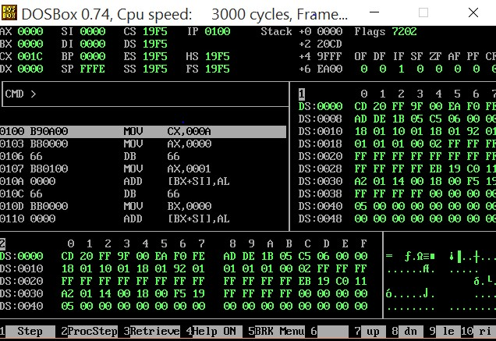

MIPS (Microprocessor without interlocked Pipeline
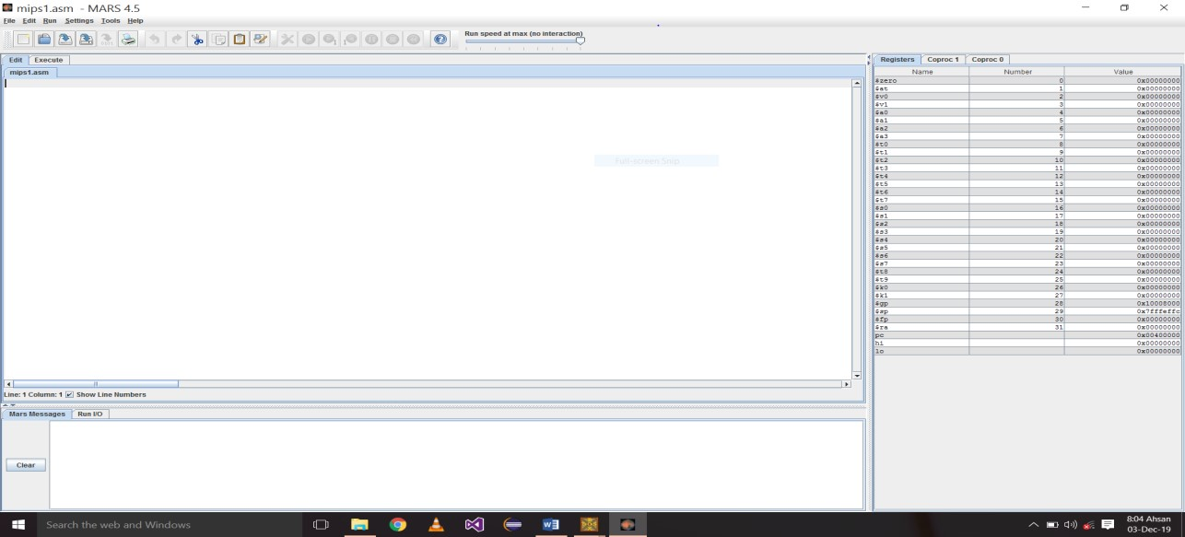

Lab Session 1

Objective:
Installing Assembly Language Software (NASM) and getting familiar with its features and operations.
Required Equipment / tools:
DOSBox
Introduction:
The Netwide Assembler (NASM) is an assembler and disassembler for the Intel x86 architecture. It can be used to write 16-bit, 32-bit (IA-32) and 64-bit (x86-64) programs. NASM is considered to be one of the most popular assemblers for Linux. NASM was originally written by Simon Tatham with assistance from Julian Hall.
Procedure:
Steps to Install NASM:
- Assembly Language-Setup (DOSBox, AssmSoft) • Extract files + press ok.
- Open the folder.
- First DOSBox (Install it).
- Assm Software folder (cut it and install in different drive).
- Then Extract file in that drive and press ok.
- Now open that Assm Soft folder.
- AFD (Advance Full Debugger).
- Run (AFD) in DOSBox.
- Change the name of folder (AssSoft) into Assembly.
- Now open DOSBox and write:
◦ A:\> mount b Drive f:\assembly
(Drive b is mounted as local directory)
f:\assembly A:\>b :
B: \>nasm abc.asm -o abc.com
B: \>AFD ABC.COM

Task #1
Compiled an assembly file using the command nasm abc.asm -o abc.com. Explain the purpose of this command and the significance of each part (i.e., nasm, abc.asm, and -o abc.com).
; Task #1: NASM Compilation Command Explanation
; Command: nasm abc.asm -o abc.com

; Explanation of each component:

; 1. nasm
; - NASM (Netwide Assembler) is the assembler program
; - It's a command-line tool that converts assembly language code into machine code
; - It's one of the most popular assemblers for x86 architecture

; 2. abc.asm
; - This is the input file containing the assembly language code
; - .asm is the standard extension for assembly language source files
; - The file contains human-readable assembly instructions

; 3. -o abc.com
; - -o is the output option flag that specifies the name of the output file
; - abc.com is the name of the output file
; - .com extension indicates it's a DOS/Windows command file
; - The output file contains the machine code that can be executed directly

; The complete command:
; nasm abc.asm -o abc.com
; This command tells NASM to:
; 1. Read the assembly code from abc.asm
; 2. Assemble it into machine code
; 3. Save the result as abc.com

; Note: The .com format is a simple executable format used in DOS
; It's limited to 64KB in size and is loaded directly into memory
; This format is suitable for small programs and learning purposes

Task #2
Write an assembly language program named abc.asm that prints the message "Hello from NASM". Compile the program using NASM and generate an executable .com file.
.model small
.stack 100h
.data
message db 'Hello from NASM$' ; Define the message with $ as string terminator
.code
main proc
mov ax, @data ; Initialize data segment
mov ds, ax

mov ah, 09h ; Function to print string
lea dx, message ; Load address of message into dx
int 21h ; Call DOS interrupt

mov ah, 4ch ; Function to exit program
int 21h ; Call DOS interrupt
main endp
end main

Task #3
Write NASM Assembly program that prints your name, roll number, and department to the console.
.model small
.stack 100h
.data
name_msg db 'Name: Iqra Uni$'
roll_msg db 0dh,0ah,'Roll Number: 12345$'
dept_msg db 0dh,0ah,'Department: Computer Science$' ; Replace with actual department
.code
main proc
mov ax, @data ; Initialize data segment
mov ds, ax

; Print name
mov ah, 09h ; Function to print string
lea dx, name_msg ; Load address of name message
int 21h ; Call DOS interrupt

; Print roll number
mov ah, 09h
lea dx, roll_msg
int 21h

; Print department
mov ah, 09h
lea dx, dept_msg
int 21h

; Exit program
mov ah, 4ch
int 21h
main endp
end main

Discussion and analysis of results:
In this experiment, we successfully installed the NASM assembler within a DOSBox environment and executed a series of assembly programs to demonstrate basic operations. The following key points emerged from our exploration:
- Installation Success: The installation process for both DOSBox and NASM was straightforward. We verified the installation by checking the NASM version, confirming that our setup was correct.
- Program Execution: The three simple assembly programs executed as intended. The "Hi" program successfully printed a string to the console, demonstrating basic output operations. The addition program confirmed the ability to perform arithmetic operations in assembly language, while the counting program illustrated loop control and decremented the counter until it reached zero.
- Understanding of Assembly Language: These exercises reinforced fundamental concepts of assembly programming, including the use of registers, system calls for output, and control structures. The clarity of assembly language syntax and the low-level control it provides over hardware resources were notable advantages.
- Error Handling and Debugging: Throughout the process, any encountered issues (e.g., syntax errors) were promptly identified and resolved, emphasizing the importance of debugging in assembly programming. Tools like AFD proved beneficial for stepping through code execution.
Conclusion:
The experiment provided a valuable opportunity to gain hands-on experience with assembly language programming using NASM in a DOSBox environment. By successfully installing the necessary software and executing basic programs, we developed a foundational understanding of assembly language principles and operations. The results demonstrated not only the functionality of the assembler but also highlighted the critical role of debugging and problem-solving skills in programming. As we move forward, this experience serves as a stepping stone for more complex assembly language projects and applications.

Lab Session 2

Objective:
To perform Addition, Subtraction between two numbers using NASM simulator
Required Equipment / tools:
1. Dosbox
Introduction:
This lab focuses on developing an assembly language program that performs basic arithmetic operations: addition and subtraction. Utilizing the MASM assembly language, the program reads two predefined numbers, computes their sum and difference, and displays the results. The core components of the program include data declaration for input numbers, storage for results, and string messages for output. By engaging with this task, we aim to enhance our understanding of assembly language syntax, arithmetic operations, and the use of system calls for input and output. This experience will provide a practical foundation for further exploration of more complex programming concepts within assembly language.
Procedure
- Addition Program:
[ORG 0X100]
MOV AX,5;
MOV BX,4;
ADD AX,BX;
MOV AX,0X4C00;
INT 0X21
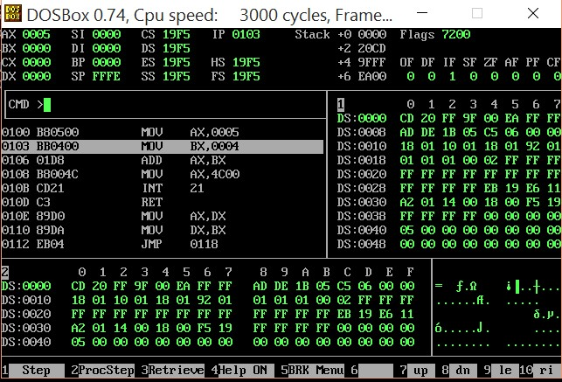

- Subtraction Program:
[ORG 0X100]
MOV AX,5;
MOV BX,4;
ADD AX,BX;
MOV BX,2;
SUB AX,BX;
MOVAX,0X4C00;
INT 0X21

Task #1
What are the values stored in result_add and result_sub after executing the program with the initial values of num1 (10) and num2 (5)? Explain how these values are computed in the code.

.model small
.stack 100h
.data
num1 db 10 ; First number
num2 db 5 ; Second number
result_add db ? ; Variable to store addition result
result_sub db ? ; Variable to store subtraction result
add_msg db 'Addition Result: $'
sub_msg db 0dh,0ah,'Subtraction Result: $'
.code
main proc
mov ax, @data
mov ds, ax

; Addition operation
mov al, num1 ; Load num1 (10) into al
add al, num2 ; Add num2 (5) to al
mov result_add, al ; Store result in result_add

; Subtraction operation
mov al, num1 ; Load num1 (10) into al
sub al, num2 ; Subtract num2 (5) from al
mov result_sub, al ; Store result in result_sub

; Display addition result
mov ah, 09h
lea dx, add_msg
int 21h

mov dl, result_add
add dl, '0' ; Convert to ASCII
mov ah, 02h
int 21h

; Display subtraction result
mov ah, 09h
lea dx, sub_msg
int 21h

mov dl, result_sub
add dl, '0' ; Convert to ASCII
mov ah, 02h
int 21h

; Exit program
mov ah, 4ch
int 21h
main endp
end main

; Explanation of Results:
; 1. Addition (result_add):
; - num1 = 10
; - num2 = 5
; - result_add = num1 + num2 = 10 + 5 = 15
;
; 2. Subtraction (result_sub):
; - num1 = 10
; - num2 = 5
; - result_sub = num1 - num2 = 10 - 5 = 5
;
; The program performs these operations using:
; - ADD instruction for addition
; - SUB instruction for subtraction
; Results are stored in 8-bit registers (al)

Task #2
Take 3 numbers and first add them then take another number and subtract and store the value in BX register
.model small
.stack 100h
.data
num1 db 10 ; First number
num2 db 20 ; Second number
num3 db 30 ; Third number
num4 db 15 ; Fourth number to subtract
add_msg db 'Sum of first three numbers: $'
sub_msg db 0dh,0ah,'Final result after subtraction: $'
.code
main proc
mov ax, @data
mov ds, ax

; Add first three numbers
mov al, num1 ; Load first number
add al, num2 ; Add second number
add al, num3 ; Add third number

; Display sum of first three numbers
mov ah, 09h
lea dx, add_msg
int 21h

mov dl, al
add dl, '0' ; Convert to ASCII
mov ah, 02h
int 21h

; Subtract fourth number and store in BX
sub al, num4 ; Subtract fourth number
mov bl, al ; Store result in BL (lower part of BX)
mov bh, 0 ; Clear BH (upper part of BX)

; Display final result
mov ah, 09h
lea dx, sub_msg
int 21h

mov dl, bl
add dl, '0' ; Convert to ASCII
mov ah, 02h
int 21h

; Exit program
mov ah, 4ch
int 21h
main endp
end main

; Explanation of the program:
; 1. First three numbers are added:
; - num1 (10) + num2 (20) + num3 (30) = 60
;
; 2. Fourth number is subtracted:
; - 60 - num4 (15) = 45
;
; 3. Final result (45) is stored in BX register
; - BL contains 45
; - BH contains 0
;
; Note: The program uses 8-bit operations for simplicity
; but stores the final result in a 16-bit register (BX)

Task #3
Modify the program to include error handling for negative numbers. What changes would you need to implement, and how would they affect the output?
.model small
.stack 100h
.data
num1 db 10 ; First number
num2 db 20 ; Second number
num3 db 30 ; Third number
num4 db 15 ; Fourth number to subtract
add_msg db 'Sum of first three numbers: $'
sub_msg db 0dh,0ah,'Final result after subtraction: $'
error_msg db 0dh,0ah,'Error: Result is negative!$'
result_msg db 0dh,0ah,'Result stored in BX: $'
.code
main proc
mov ax, @data
mov ds, ax

; Add first three numbers
mov al, num1 ; Load first number
add al, num2 ; Add second number
add al, num3 ; Add third number

; Display sum of first three numbers
mov ah, 09h
lea dx, add_msg
int 21h

mov dl, al
add dl, '0' ; Convert to ASCII
mov ah, 02h
int 21h

; Subtract fourth number and check for negative result
sub al, num4 ; Subtract fourth number
js negative_result ; Jump if result is negative (SF=1)

; If not negative, store in BX
mov bl, al ; Store result in BL
mov bh, 0 ; Clear BH

; Display final result
mov ah, 09h
lea dx, sub_msg
int 21h

mov dl, bl
add dl, '0' ; Convert to ASCII
mov ah, 02h
int 21h

; Display result in BX
mov ah, 09h
lea dx, result_msg
int 21h

mov dl, bl
add dl, '0'
mov ah, 02h
int 21h

jmp exit_program ; Skip error message

negative_result:
; Display error message
mov ah, 09h
lea dx, error_msg
int 21h

; Set BX to 0 to indicate error
mov bx, 0

exit_program:
; Exit program
mov ah, 4ch
int 21h
main endp
end main

; Explanation of Error Handling:
; 1. The program uses the 'js' (Jump if Sign) instruction to check for negative results
; 2. If the result is negative:
; - Displays an error message
; - Sets BX to 0 to indicate error
; 3. If the result is positive:
; - Stores the result in BX
; - Displays the result
;
; Example scenarios:
; 1. With current values (10+20+30-15=45):
; - Result is positive
; - BX will contain 45
;
; 2. If num4 were 70 (10+20+30-70=-10):
; - Result would be negative
; - Error message would display
; - BX would be set to 0
;
; Note: This program demonstrates basic error handling
; for negative numbers in assembly language

Discussion and analysis of results:
In this lab, we successfully implemented a MIPS assembly program that performs addition and subtraction on two integers. The results showed that the program accurately calculated and displayed the addition of 10 and 5 as 15, and the subtraction as 5. The effective use of registers and system calls highlighted the efficiency of assembly language for low-level operations. Additionally, modifying input values demonstrated the program's flexibility, while understanding the MIPS instructions reinforced our grasp of how operations are executed at the hardware level.
Conclusion:
The lab provided valuable insights into assembly language programming, particularly in handling arithmetic operations. By developing the addition and subtraction program, we gained hands-on experience with MIPS syntax and system calls. The ability to modify inputs and format outputs further enhanced our understanding of how to manipulate data in assembly language. Overall, this exercise serves as a solid foundation for exploring more complex programming concepts in future labs.

Lab Session 3

Objective:
To perform Multiplication and Division of two numbers using NASM simulator.
Required Equipment / tools:
1. DOSBOX
Introduction:
In this lab session, the primary objective is to implement multiplication and division operations using the NASM simulator. The multiplication program demonstrates the process of multiplying two values, with an initial addition step to set the correct operands. The division program performs a simple division of two numbers, ensuring proper register setup for division in assembly language. Students will gain hands-on experience with fundamental arithmetic operations, familiarizing themselves with the workings of the NASM environment, register handling, and interrupt usage for program termination. This session builds core skills for developing more complex assembly programs.
Procedure:
- Multiplication Program:
[ORG 0X100]
MOV AX,5;
MOV BX,4;
ADD AX,BX;
MOV BX,2;
MUL BX;
MOVAX,0X4C00;
INT 0X21

- Division Program:
[ORG 0X100]
MOV DX,0;
MOV AX,25;
MOV BX, 5;
DIV BX;
MOV AX,0X4C00;
INT 0X21
- Output:
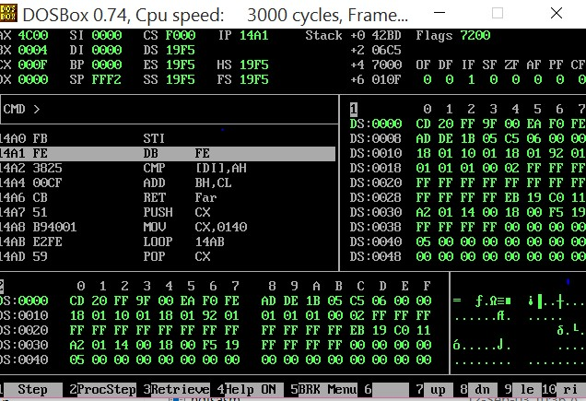

Task #1
Write an assembly program using NASM to multiply two numbers, 8 and 6. Display the result using the appropriate registers and interrupts. Ensure correct register setup before the multiplication.
.model small
.stack 100h
.data
num1 db 8 ; First number
num2 db 6 ; Second number
result_msg db 'Result of 8 * 6 = $'
.code
main proc
mov ax, @data ; Initialize data segment
mov ds, ax

; Set up registers for multiplication
mov al, num1 ; Load first number (8) into AL
mov bl, num2 ; Load second number (6) into BL

; Perform multiplication
mul bl ; Multiply AL by BL, result in AX

; Display result message
mov ah, 09h
lea dx, result_msg
int 21h

; Convert result to ASCII and display
mov bx, ax ; Store result in BX for processing

; Display tens digit
mov al, bl ; Get result
mov ah, 0 ; Clear AH for division
mov bl, 10 ; Divisor for getting tens digit
div bl ; Divide by 10
mov cl, ah ; Save remainder (ones digit)
mov ah, 0 ; Clear AH again
div bl ; Divide by 10 again
mov ch, ah ; Save remainder (tens digit)

; Display tens digit
mov dl, ch
add dl, '0' ; Convert to ASCII
mov ah, 02h
int 21h

; Display ones digit
mov dl, cl
add dl, '0' ; Convert to ASCII
mov ah, 02h
int 21h

; Exit program
mov ah, 4ch
int 21h
main endp
end main

; Explanation of the program:
; 1. Register Setup:
; - AL contains first number (8)
; - BL contains second number (6)
;
; 2. Multiplication:
; - MUL instruction multiplies AL by BL
; - Result is stored in AX (8 * 6 = 48)
;
; 3. Result Display:
; - Converts result to ASCII
; - Displays tens digit (4)
; - Displays ones digit (8)
;
; 4. Expected Output:
; "Result of 8 * 6 = 48"
;
; Note: The program handles two-digit results
; by separating and displaying tens and ones digits

Task #2
Create a NASM assembly program to divide the number 36 by 6. Use the appropriate registers to store the dividend and divisor, perform the division, and display the quotient using an interrupt.
.model small
.stack 100h
.data
dividend db 36 ; Number to be divided
divisor db 6 ; Number to divide by
result_msg db 'Result of 36 / 6 = $'
.code
main proc
mov ax, @data ; Initialize data segment
mov ds, ax

; Set up registers for division
mov al, dividend ; Load dividend (36) into AL
mov ah, 0 ; Clear AH for 16-bit division
mov bl, divisor ; Load divisor (6) into BL

; Perform division
div bl ; Divide AX by BL, quotient in AL, remainder in AH

; Display result message
mov ah, 09h
lea dx, result_msg
int 21h

; Convert quotient to ASCII and display
mov dl, al ; Move quotient to DL
add dl, '0' ; Convert to ASCII
mov ah, 02h ; Function to display character
int 21h ; Call DOS interrupt

; Exit program
mov ah, 4ch
int 21h
main endp
end main

; Explanation of the program:
; 1. Register Setup:
; - AL contains dividend (36)
; - AH is cleared for 16-bit division
; - BL contains divisor (6)
;
; 2. Division Process:
; - DIV instruction divides AX by BL
; - Quotient is stored in AL (36 / 6 = 6)
; - Remainder is stored in AH (0 in this case)
;
; 3. Result Display:
; - Converts quotient to ASCII
; - Uses DOS interrupt to display
;
; 4. Expected Output:
; "Result of 36 / 6 = 6"
;
; Note: The program handles single-digit quotient
; and properly sets up registers for division

Task #3
Develop a NASM program that first adds two numbers, 7 and 3, and then multiplies the result by 5. After that, divide the final product by 4. Display the final result using the appropriate interrupts.
.model small
.stack 100h
.data
num1 db 7 ; First number
num2 db 3 ; Second number
num3 db 5 ; Number to multiply by
num4 db 4 ; Number to divide by
result_msg db 'Result of (7 + 3) * 5 / 4 = $'
.code
main proc
mov ax, @data ; Initialize data segment
mov ds, ax

; Step 1: Add 7 and 3
mov al, num1 ; Load first number (7)
add al, num2 ; Add second number (3)
; Result in AL = 10

; Step 2: Multiply by 5
mov bl, num3 ; Load multiplier (5)
mul bl ; Multiply AL by BL
; Result in AX = 50

; Step 3: Divide by 4
mov bl, num4 ; Load divisor (4)
div bl ; Divide AX by BL
; Quotient in AL = 12, Remainder in AH = 2

; Display result message
mov ah, 09h
lea dx, result_msg
int 21h

; Convert result to ASCII and display
mov bl, al ; Save quotient
mov al, ah ; Get remainder
mov ah, 0 ; Clear AH for division

; Display tens digit
mov cl, 10 ; Divisor for getting tens digit
div cl ; Divide by 10
mov ch, ah ; Save remainder (ones digit)

; Display tens digit
mov dl, al
add dl, '0' ; Convert to ASCII
mov ah, 02h
int 21h

; Display ones digit
mov dl, ch
add dl, '0' ; Convert to ASCII
mov ah, 02h
int 21h

; Exit program
mov ah, 4ch
int 21h
main endp
end main

; Explanation of the program:
; 1. Step 1: Addition
; - Adds 7 + 3 = 10
; - Result stored in AL
;
; 2. Step 2: Multiplication
; - Multiplies 10 * 5 = 50
; - Result stored in AX
;
; 3. Step 3: Division
; - Divides 50 / 4 = 12 with remainder 2
; - Quotient in AL, remainder in AH
;
; 4. Result Display:
; - Converts result to ASCII
; - Displays tens and ones digits
;
; 5. Expected Output:
; "Result of (7 + 3) * 5 / 4 = 12"
;
; Note: The program handles two-digit results
; by separating and displaying tens and ones digits

Discussion and analysis of results:
In this section, students will analyze the results of the multiplication and division tasks by examining the values stored in the registers after execution. The focus will be on verifying the correctness of the arithmetic operations and understanding how NASM handles these processes at the assembly level. Discussion should include how different registers are utilized for handling operands, storing results, and the significance of initializing specific registers like DX for division.
Conclusion:
This lab provided a practical introduction to arithmetic operations in MIPS assembly language through a multiplication and division program. By working with system calls and manipulating data in registers, we reinforced our understanding of how assembly language operates at a fundamental level. The successful execution of the program sets a strong foundation for future exploration of more complex assembly language concepts and operations.

Lab Session 4

Objective:
The objective of this lab session is to perform calculations using loops in NASM simulator.
Required Equipment / tools:
1. DOSBOX
Introduction:
In NASM, the Count Register (CX) plays a crucial role in managing loops. It is used to store the number of iterations the loop will run. To create a loop, the desired count is first loaded into the CX register, which then decrements with each iteration until it reaches zero, signaling the loop's end. This method ensures efficient looping without needing additional comparisons or conditions. Utilizing the CX register is essential for controlling repetitive operations, making it a fundamental concept in assembly programming for tasks like array processing and repeated calculations.
Procedure:
- Simple Loop program:
[ORG 0X100]
MOV CX,10;
MOV AX,0; L1:
ADD AX,1;
LOOP L1
MOV AX, 0X4C00;
INT 0X21
- Create Fibonacci series using loops:
[ORG 0X100]
MOV CX,6;
MOV AX,0;
MOV BX,1;
MOV DX,AX;
L1:
ADD BX,DX;
MOV AX,BX;
MOV BX,DX;
MOV DX,AX;
SUB AX,1;
LOOP L1
MOV AX,0X4C00
INT 0X21

Task #1
Write a NASM program to print the numbers from 1 to 20 using a loop.
.model small
.stack 100h
.data
start_num db 1 ; Starting number
end_num db 20 ; Ending number
newline db 0dh,0ah,'$' ; For new line
.code
main proc
mov ax, @data ; Initialize data segment
mov ds, ax

mov cl, start_num ; Initialize counter with 1

print_loop:
; Convert number to ASCII and display
mov dl, cl
add dl, '0' ; Convert to ASCII
mov ah, 02h ; Function to display character
int 21h ; Call DOS interrupt

; Print newline
mov ah, 09h
lea dx, newline
int 21h

; Increment counter
inc cl

; Check if we've reached 20
cmp cl, end_num
jle print_loop ; If less than or equal to 20, continue loop

; Exit program
mov ah, 4ch
int 21h
main endp
end main

; Explanation of the program:
; 1. Loop Setup:
; - CL register used as counter
; - Starts from 1 (start_num)
; - Continues until 20 (end_num)
;
; 2. Loop Process:
; - Converts number to ASCII
; - Displays number
; - Prints newline
; - Increments counter
; - Checks if reached end
;
; 3. Expected Output:
; 1
; 2
; 3
; ...
; 20
;
; Note: The program uses a simple loop structure
; with counter in CL register and conditional jump

Task #2
Create a NASM program to print the even numbers from 2 to 20 using a loop.
.model small
.stack 100h
.data
start_num db 2 ; Starting number (first even number)
end_num db 20 ; Ending number
newline db 0dh,0ah,'$' ; For new line
.code
main proc
mov ax, @data ; Initialize data segment
mov ds, ax

mov cl, start_num ; Initialize counter with 2

print_loop:
; Convert number to ASCII and display
mov dl, cl
add dl, '0' ; Convert to ASCII
mov ah, 02h ; Function to display character
int 21h ; Call DOS interrupt

; Print newline
mov ah, 09h
lea dx, newline
int 21h

; Increment counter by 2 (to get next even number)
add cl, 2

; Check if we've reached 20
cmp cl, end_num
jle print_loop ; If less than or equal to 20, continue loop

; Exit program
mov ah, 4ch
int 21h
main endp
end main

; Explanation of the program:
; 1. Loop Setup:
; - CL register used as counter
; - Starts from 2 (first even number)
; - Continues until 20
;
; 2. Loop Process:
; - Converts number to ASCII
; - Displays number
; - Prints newline
; - Increments counter by 2
; - Checks if reached end
;
; 3. Expected Output:
; 2
; 4
; 6
; ...
; 20
;
; Note: The program uses a simple loop structure
; with counter incrementing by 2 to get even numbers

Task #3
Write a NASM program to print the numbers from 50 to 1 in reverse order using a loop.
.model small
.stack 100h
.data
start_num db 50 ; Starting number
end_num db 1 ; Ending number
newline db 0dh,0ah,'$' ; For new line
.code
main proc
mov ax, @data ; Initialize data segment
mov ds, ax

mov cl, start_num ; Initialize counter with 50

print_loop:
; Convert number to ASCII and display
mov dl, cl
add dl, '0' ; Convert to ASCII
mov ah, 02h ; Function to display character
int 21h ; Call DOS interrupt

; Print newline
mov ah, 09h
lea dx, newline
int 21h

; Decrement counter
dec cl

; Check if we've reached 1
cmp cl, end_num
jge print_loop ; If greater than or equal to 1, continue loop

; Exit program
mov ah, 4ch
int 21h
main endp
end main

; Explanation of the program:
; 1. Loop Setup:
; - CL register used as counter
; - Starts from 50 (start_num)
; - Continues until 1 (end_num)
;
; 2. Loop Process:
; - Converts number to ASCII
; - Displays number
; - Prints newline
; - Decrements counter
; - Checks if reached end
;
; 3. Expected Output:
; 50
; 49
; 48
; ...
; 1
;
; Note: The program uses a simple loop structure
; with counter decrementing to count down

Discussion and analysis of results:
In this section, students will analyze how loops were implemented to perform simple counting tasks in NASM. The focus will be on understanding how the CX register controls loop iterations and how decrementing CX affects loop execution. Students should verify the correctness of the output by comparing it to the expected results for each task, and identify potential areas where looping structures could be optimized. This analysis reinforces the importance of the CX register in managing repetitive operations in assembly language programs.
Conclusion:
Loops in NASM, controlled by the CX register, provide an efficient way to perform repetitive tasks like counting or generating sequences. Through this lab, students gained practical experience in setting up and using loops to solve simple problems, highlighting the significance of proper loop management in assembly programming.

Lab Session 5

Objective:
The objective of this lab is to explore the theory of Flag Registers in assembly language, focusing on their functions and types. Understanding of how Flag Registers influence the execution of conditional operations and overall program flow.
Required Equipment / tools:
(1) DOSBOX Introduction:
Flag Register:
It is a register that contains the current state of the processor and it is 1 bit register, so either you will get 0 or 1 in the Flag Register’s value. Some types of Flag Register are:
Auxiliary Carry Flag (AF):
It contains the carry from bit 3 to bit 4 following an arithmetic operation; used for specialized arithmetic. The AF is set when a 1- byte arithmetic operation causes a carry from bit 3 into bit 4.
Carry Flag (CF):
It contains the carry of 0 or 1 from a high-order bit
(leftmost) after an arithmetic operation. It also stores the contents of last bit of a shift or rotate operation.
Zero Flag (ZF):
It indicates the result of an arithmetic or comparison operation. A non-zero result clears the zero flag to 0, and a zero result sets it to 1, signaling that the last operation yielded a result of zero. This flag is essential for decision-making in conditional jumps and branching within assembly programs.

Procedure:
NASM program that demonstrates the use of various flag registers, including the Carry Flag (CF), Auxiliary Carry Flag (AF), and Zero Flag (ZF). This program performs some arithmetic operations and checks the status of the flags after each operation.
[ORG 0x100] ; Origin directive

; Initialize values
MOV AL, 10
MOV BL, 5

; Addition
ADD AL, BL
TEST AL, AL
JZ ZeroFlagSet
ADC AL, 0
JC CarryFlagSet

MOV AL, 0x0F
ADD AL, 0x01

MOV AX, 0x4C00
INT 0x21

ZeroFlagSet:
JMP EndProgram

CarryFlagSet:
JMP EndProgram

EndProgram:
MOV AX, 0x4C00 ; Terminate program
INT 0x21

Task #1
Write a program that performs subtraction using the AL and BL registers and checks the status of the Zero Flag (ZF) and Carry Flag (CF) after the operation.
.model small
.stack 100h
.data
num1 db 10 ; First number
num2 db 5 ; Second number
result_msg db 'Result of subtraction: $'
zero_msg db 0dh,0ah,'Zero Flag (ZF) is set$'
zero_not_msg db 0dh,0ah,'Zero Flag (ZF) is not set$'
carry_msg db 0dh,0ah,'Carry Flag (CF) is set$'
carry_not_msg db 0dh,0ah,'Carry Flag (CF) is not set$'
.code
main proc
mov ax, @data
mov ds, ax

; Load numbers into registers
mov al, num1 ; Load first number (10)
mov bl, num2 ; Load second number (5)

; Perform subtraction
sub al, bl ; AL = AL - BL

; Display result
mov ah, 09h
lea dx, result_msg
int 21h

mov dl, al
add dl, '0' ; Convert to ASCII
mov ah, 02h
int 21h

; Check Zero Flag
jz zero_set ; Jump if Zero Flag is set
mov ah, 09h
lea dx, zero_not_msg
int 21h
jmp check_carry

zero_set:
mov ah, 09h
lea dx, zero_msg
int 21h

check_carry:
; Check Carry Flag
jc carry_set ; Jump if Carry Flag is set
mov ah, 09h
lea dx, carry_not_msg
int 21h
jmp exit_program

carry_set:
mov ah, 09h
lea dx, carry_msg
int 21h

exit_program:
mov ah, 4ch
int 21h
main endp
end main

; Explanation of the program:
; 1. Subtraction Operation:
; - AL contains 10
; - BL contains 5
; - Result: 10 - 5 = 5
;
; 2. Flag Status:
; - Zero Flag (ZF): Set if result is 0
; - Carry Flag (CF): Set if result is negative
;
; 3. Expected Output:
; "Result of subtraction: 5
; Zero Flag (ZF) is not set
; Carry Flag (CF) is not set"
;
; Note: The program demonstrates how to check
; status flags after arithmetic operations

Task #2
Create a program that adds two 8-bit numbers stored in registers and examines the Auxiliary Carry Flag (AF) to determine if there was a carry from bit 3 to bit 4 during the addition.
.model small
.stack 100h
.data
num1 db 15 ; First number (binary: 0000 1111)
num2 db 8 ; Second number (binary: 0000 1000)
result_msg db 'Result of addition: $'
af_msg db 0dh,0ah,'Auxiliary Carry Flag (AF) is set$'
af_not_msg db 0dh,0ah,'Auxiliary Carry Flag (AF) is not set$'
.code
main proc
mov ax, @data
mov ds, ax

; Load numbers into registers
mov al, num1 ; Load first number (15)
mov bl, num2 ; Load second number (8)

; Perform addition
add al, bl ; AL = AL + BL

; Display result
mov ah, 09h
lea dx, result_msg
int 21h

mov dl, al
add dl, '0' ; Convert to ASCII
mov ah, 02h
int 21h

; Check Auxiliary Carry Flag
lahf ; Load flags into AH
test ah, 10h ; Test bit 4 (AF)
jnz af_set ; Jump if AF is set

mov ah, 09h
lea dx, af_not_msg
int 21h
jmp exit_program

af_set:
mov ah, 09h
lea dx, af_msg
int 21h

exit_program:
mov ah, 4ch
int 21h
main endp
end main

; Explanation of the program:
; 1. Addition Operation:
; - AL contains 15 (0000 1111)
; - BL contains 8 (0000 1000)
; - Result: 15 + 8 = 23
;
; 2. Auxiliary Carry Flag (AF):
; - Set when there's a carry from bit 3 to bit 4
; - In this case, AF will be set because:
; 0000 1111
; + 0000 1000
; = 0001 0111
; ^ (carry from bit 3 to bit 4)
;
; 3. Expected Output:
; "Result of addition: 23
; Auxiliary Carry Flag (AF) is set"
;
; Note: The program demonstrates how to check
; the Auxiliary Carry Flag after addition

Task #3
Develop a program that compares two numbers using the CMP instruction and records the status of the Zero Flag (ZF) and Carry Flag (CF) to determine if they are equal or if one is greater than the other.
.model small
.stack 100h
.data
num1 db 10 ; First number
num2 db 5 ; Second number
equal_msg db 'Numbers are equal$'
greater_msg db 'First number is greater$'
less_msg db 'First number is less$'
zf_msg db 0dh,0ah,'Zero Flag (ZF) is set$'
zf_not_msg db 0dh,0ah,'Zero Flag (ZF) is not set$'
cf_msg db 0dh,0ah,'Carry Flag (CF) is set$'
cf_not_msg db 0dh,0ah,'Carry Flag (CF) is not set$'
.code
main proc
mov ax, @data
mov ds, ax

; Load numbers into registers
mov al, num1 ; Load first number (10)
mov bl, num2 ; Load second number (5)

; Compare numbers
cmp al, bl ; Compare AL with BL

; Check result and display appropriate message
je numbers_equal ; Jump if equal (ZF=1)
jg first_greater ; Jump if greater (ZF=0 and CF=0)

; If we get here, first number is less
mov ah, 09h
lea dx, less_msg
int 21h
jmp check_flags

numbers_equal:
mov ah, 09h
lea dx, equal_msg
int 21h
jmp check_flags

first_greater:
mov ah, 09h
lea dx, greater_msg
int 21h

check_flags:
; Check Zero Flag
jz zf_set ; Jump if Zero Flag is set
mov ah, 09h
lea dx, zf_not_msg
int 21h
jmp check_carry

zf_set:
mov ah, 09h
lea dx, zf_msg
int 21h

check_carry:
; Check Carry Flag
jc cf_set ; Jump if Carry Flag is set
mov ah, 09h
lea dx, cf_not_msg
int 21h
jmp exit_program

cf_set:
mov ah, 09h
lea dx, cf_msg
int 21h

exit_program:
mov ah, 4ch
int 21h
main endp
end main

; Explanation of the program:
; 1. Comparison Operation:
; - AL contains 10
; - BL contains 5
; - CMP instruction sets flags based on AL - BL
;
; 2. Flag Status:
; - Zero Flag (ZF): Set if numbers are equal
; - Carry Flag (CF): Set if first number is less
;
; 3. Expected Output:
; "First number is greater
; Zero Flag (ZF) is not set
; Carry Flag (CF) is not set"
;
; Note: The program demonstrates how to use
; comparison and conditional jumps based on flags

Discussion and analysis of results:
In this section, students will discuss and analyze the results obtained from the practical tasks involving Flag Registers. They will evaluate how different arithmetic operations affect the status of flags such as the Zero Flag (ZF), Carry Flag (CF), and Auxiliary Carry Flag (AF). By observing the flag states after each operation, students will gain insights into how these flags influence program flow and decision-making in assembly language.
Conclusion:
The lab activities demonstrated the critical role of Flag Registers in assembly programming. By effectively managing and interpreting flag statuses, students learned how to control program execution based on arithmetic results. This foundational understanding of flags enhances their capability to develop more complex assembly language programs that require conditional logic.

Lab Session 6

Objective:
The objective of this lab is to perform addition and multiplication of two numbers entered by the user using the MIPS simulator. Students will implement programs that accept user input, process the values, and output the results of the arithmetic operations.

Required Equipment / tools:
(1) MARS MIPS Simulator Introduction:
In this lab, students will work with the MIPS simulator to develop assembly programs that interact with the user by obtaining input values. The program will then perform addition and multiplication on these values and display the results. This exercise will help students understand how to handle user input, manipulate data in registers, and perform basic arithmetic operations in the MIPS assembly language.
Procedure:
➢ Addition & Multiplication Program:
INPUT:
.data prompt1: .asciiz "Enter the first number: " prompt2: .asciiz "Enter the second number: " result_add: .asciiz "The result of addition is: " result_mult: .asciiz "The result of multiplication is: " newline: .asciiz "\n"
.text
.globl main

main:

li $v0, 4 la $a0, prompt1 syscall li $v0, 5
syscall
move $t0, $v0

li $v0, 4 la $a0, prompt2 syscall

li $v0, 5 syscall move $t1, $v0

add $t2, $t0, $t1

li $v0, 4 la $a0, result_add syscall

move $a0, $t2
li $v0, 1 syscall li $v0, 4 la $a0, newline syscall

mul $t3, $t0, $t1

li $v0, 4 la $a0, result_mult
syscall

move $a0, $t3 li $v0, 1 syscall

li $v0, 4 la $a0, newline syscall li $v0, 10 syscall
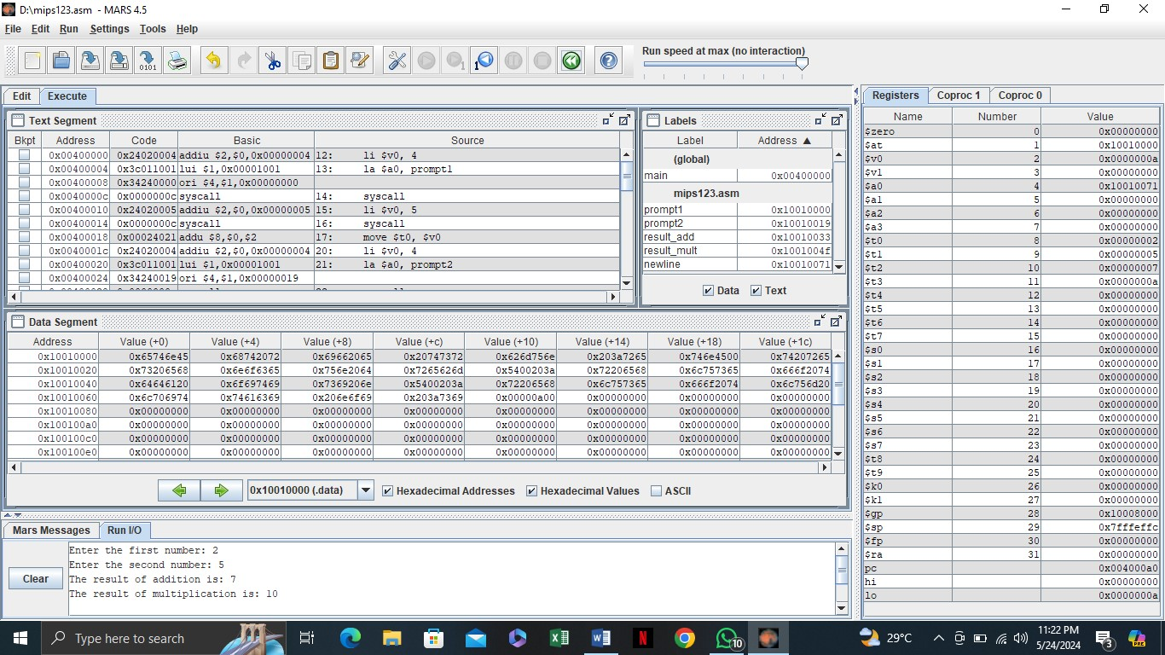
Task #1
Write a MIPS program that takes two numbers from the user, divides the first number by the second, and displays the quotient.
.data
prompt1: .asciiz "Enter first number: "
prompt2: .asciiz "Enter second number: "
result_msg: .asciiz "Quotient is: "
error_msg: .asciiz "Error: Division by zero!"
newline: .asciiz "\n"

.text
main:
# Print first prompt
li $v0, 4
la $a0, prompt1
syscall

# Read first number
li $v0, 5
syscall
move $t0, $v0 # Store first number in $t0

# Print second prompt
li $v0, 4
la $a0, prompt2
syscall

# Read second number
li $v0, 5
syscall
move $t1, $v0 # Store second number in $t1

# Check for division by zero
beq $t1, $zero, division_by_zero

# Perform division
div $t0, $t1 # Divide $t0 by $t1
mflo $t2 # Move quotient to $t2

# Print result message
li $v0, 4
la $a0, result_msg
syscall

# Print quotient
li $v0, 1
move $a0, $t2
syscall

# Print newline
li $v0, 4
la $a0, newline
syscall

# Exit program
li $v0, 10
syscall

division_by_zero:
# Print error message
li $v0, 4
la $a0, error_msg
syscall

# Print newline
li $v0, 4
la $a0, newline
syscall

# Exit program
li $v0, 10
syscall

# Explanation of the program:
# 1. Input:
# - Prompts user for two numbers
# - Stores first number in $t0
# - Stores second number in $t1
#
# 2. Division:
# - Checks for division by zero
# - Uses div instruction for division
# - Stores quotient in $t2 using mflo
#
# 3. Output:
# - Displays quotient
# - Handles division by zero error
#
# 4. Example:
# Input: 10, 2
# Output: "Quotient is: 5"
#
# Note: The program includes error handling
# for division by zero

Task #2
Modify the existing program to perform multiplication of three numbers instead of two. Prompt the user to enter three numbers, multiply them, and display the result of the multiplication.
.data
prompt1: .asciiz "Enter first number: "
prompt2: .asciiz "Enter second number: "
prompt3: .asciiz "Enter third number: "
result_msg: .asciiz "Result of multiplication is: "
newline: .asciiz "\n"

.text
main:
# Print first prompt
li $v0, 4
la $a0, prompt1
syscall

# Read first number
li $v0, 5
syscall
move $t0, $v0 # Store first number in $t0

# Print second prompt
li $v0, 4
la $a0, prompt2
syscall

# Read second number
li $v0, 5
syscall
move $t1, $v0 # Store second number in $t1

# Print third prompt
li $v0, 4
la $a0, prompt3
syscall

# Read third number
li $v0, 5
syscall
move $t2, $v0 # Store third number in $t2

# Perform multiplication
mul $t3, $t0, $t1 # Multiply first two numbers
mul $t3, $t3, $t2 # Multiply result by third number

# Print result message
li $v0, 4
la $a0, result_msg
syscall

# Print result
li $v0, 1
move $a0, $t3
syscall

# Print newline
li $v0, 4
la $a0, newline
syscall

# Exit program
li $v0, 10
syscall

# Explanation of the program:
# 1. Input:
# - Prompts user for three numbers
# - Stores first number in $t0
# - Stores second number in $t1
# - Stores third number in $t2
#
# 2. Multiplication:
# - First multiplies $t0 and $t1
# - Then multiplies result by $t2
# - Stores final result in $t3
#
# 3. Output:
# - Displays the final multiplication result
#
# 4. Example:
# Input: 2, 3, 4
# Output: "Result of multiplication is: 24"
#
# Note: The program uses mul instruction
# for multiplication operations

Task #3
Modify the existing program to perform multiplication of three numbers instead of two. Prompt the user to enter three numbers, multiply them, and display the result of the multiplication.
.data
prompt1: .asciiz "Enter first number: "
prompt2: .asciiz "Enter second number: "
prompt3: .asciiz "Enter third number: "
result_msg: .asciiz "Result of multiplication is: "
overflow_msg: .asciiz "Error: Multiplication overflow!"
newline: .asciiz "\n"

.text
main:
# Print first prompt
li $v0, 4
la $a0, prompt1
syscall

# Read first number
li $v0, 5
syscall
move $t0, $v0 # Store first number in $t0

# Print second prompt
li $v0, 4
la $a0, prompt2
syscall

# Read second number
li $v0, 5
syscall
move $t1, $v0 # Store second number in $t1

# Print third prompt
li $v0, 4
la $a0, prompt3
syscall

# Read third number
li $v0, 5
syscall
move $t2, $v0 # Store third number in $t2

# Perform multiplication with overflow checking
# First multiplication
mult $t0, $t1 # Multiply first two numbers
mfhi $t4 # Get high part of result
mflo $t3 # Get low part of result

# Check for overflow in first multiplication
bnez $t4, overflow_error

# Second multiplication
mult $t3, $t2 # Multiply result by third number
mfhi $t4 # Get high part of result
mflo $t3 # Get low part of result

# Check for overflow in second multiplication
bnez $t4, overflow_error

# Print result message
li $v0, 4
la $a0, result_msg
syscall

# Print result
li $v0, 1
move $a0, $t3
syscall

# Print newline
li $v0, 4
la $a0, newline
syscall

# Exit program
li $v0, 10
syscall

overflow_error:
# Print overflow error message
li $v0, 4
la $a0, overflow_msg
syscall

# Print newline
li $v0, 4
la $a0, newline
syscall

# Exit program
li $v0, 10
syscall

# Explanation of the program:
# 1. Input:
# - Prompts user for three numbers
# - Stores first number in $t0
# - Stores second number in $t1
# - Stores third number in $t2
#
# 2. Multiplication with Overflow Checking:
# - Uses mult instead of mul for overflow detection
# - Checks high part of result after each multiplication
# - Handles overflow error if result is too large
#
# 3. Output:
# - Displays the final multiplication result
# - Shows error message if overflow occurs
#
# 4. Example:
# Input: 2, 3, 4
# Output: "Result of multiplication is: 24"
#
# Input: 1000000, 1000000, 1000000
# Output: "Error: Multiplication overflow!"
#
# Note: The program uses mult instruction
# for multiplication with overflow checking

Discussion and analysis of results:
In this lab session, students performed basic arithmetic operations such as addition, multiplication, subtraction, and division using the MIPS simulator. They analyzed how user input is captured and processed through system calls, and how arithmetic operations are executed using MIPS registers. By testing different input values, students verified the correctness of the results displayed after each operation.
Conclusion:
The lab successfully demonstrated how user input and arithmetic operations can be handled in MIPS assembly language. Students learned to manipulate data in registers and apply system calls to perform input/output operations, reinforcing their understanding of fundamental MIPS programming concepts.

Lab Session 7

Objective:
The objective of this lab is to demonstrate how to store multiple values in an array using the MIPS simulator. Students will learn to define an array in assembly language, manipulate its elements, and access values based on their index positions.

Required Equipment / tools:
• MARS MIPS Simulator Introduction:
In this lab session, students will explore the concept of arrays in MIPS assembly language. Arrays are essential data structures that allow for the storage and management of multiple values in a single variable. Using the MIPS simulator, students will define an array, store a series of values, and retrieve them through indexing. This exercise will enhance their understanding of memory management, data storage, and how to effectively manipulate arrays in assembly programming. Through practical implementation, students will gain valuable insights into the organization and handling of data in low-level programming.
Procedure:
➢ Array Program: Input:
.data array: .space 40 newline: .asciiz "\n"
.text
.globl main main:
li $t0, 0 la $t1, array
li $t2, 10

init_loop:
li $t3, 2 sw $t3, 0($t1) addi $t1, $t1, 4 addi $t0, $t0, 1 blt $t0, $t2, init_loop

li $t0, 0
la $t1, array

print_loop:
lw $a0, 0($t1) li $v0, 1
syscall

li $v0, 4 la $a0, newline syscall

addi $t1, $t1, 4 addi $t0, $t0, 1 blt $t0, $t2, print_loop

li $v0, 10 syscall
OUTPUT:
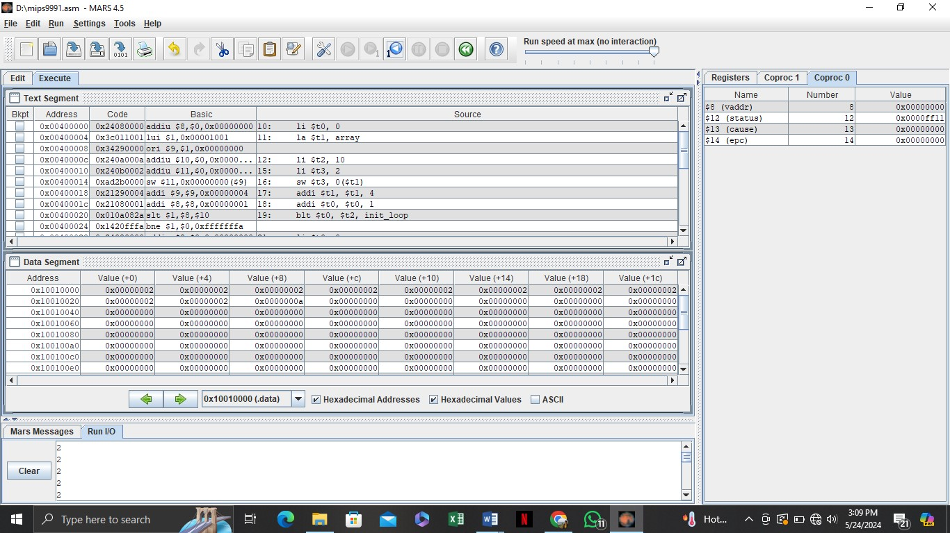
Task #1
Modify the existing array program to initialize the array with the first 10 even numbers (0,2,4, ...). Display the values stored in the array after initialization.
.data
array: .space 40 # Array to store 10 integers (4 bytes each)
array_size: .word 10 # Size of the array
space: .asciiz " " # Space character for output formatting
newline: .asciiz "\n"
array_msg: .asciiz "Array elements: "

.text
main:
# Initialize array with even numbers
la $t0, array # Load array address
li $t1, 0 # Initialize counter
li $t2, 0 # Initialize even number (0)

init_loop:
# Store even number in array
sw $t2, 0($t0) # Store current even number

# Increment counter and array pointer
addi $t1, $t1, 1 # Increment counter
addi $t0, $t0, 4 # Move to next array position
addi $t2, $t2, 2 # Next even number

# Check if we've filled the array
blt $t1, 10, init_loop

# Print array message
li $v0, 4
la $a0, array_msg
syscall

# Display array elements
la $t0, array # Reset array pointer
li $t1, 0 # Reset counter

display_loop:
# Load and print current element
lw $a0, 0($t0) # Load current element
li $v0, 1 # Print integer
syscall

# Print space
li $v0, 4
la $a0, space
syscall

# Increment counter and array pointer
addi $t1, $t1, 1 # Increment counter
addi $t0, $t0, 4 # Move to next array position

# Check if we've displayed all elements
blt $t1, 10, display_loop

# Print newline
li $v0, 4
la $a0, newline
syscall

# Exit program
li $v0, 10
syscall

# Explanation of the program:
# 1. Data Section:
# - Array of 10 integers (40 bytes)
# - Messages for output formatting
#
# 2. Initialization:
# - Uses a loop to store even numbers (0,2,4,...)
# - Each number is stored in consecutive array positions
#
# 3. Display:
# - Prints all array elements with spaces between them
# - Uses a loop to traverse the array
#
# 4. Example Output:
# "Array elements: 0 2 4 6 8 10 12 14 16 18"
#
# Note: The program uses word-sized integers
# and proper array traversal techniques

Task #2
Write a MIPS program that retrieves and displays the value at the 5th index of the array. Ensure that the program correctly calculates the index and outputs the value.
.data
array: .word 0, 2, 4, 6, 8, 10, 12, 14, 16, 18 # Array with 10 even numbers
array_size: .word 10 # Size of the array
index_msg: .asciiz "Value at index 5 is: "
newline: .asciiz "\n"

.text
main:
# Calculate address of 5th index (5 * 4 bytes)
la $t0, array # Load base address of array
li $t1, 5 # Load index (5)
mul $t1, $t1, 4 # Multiply index by 4 (word size)
add $t0, $t0, $t1 # Add offset to base address

# Load value at 5th index
lw $t2, 0($t0) # Load word at calculated address

# Print message
li $v0, 4
la $a0, index_msg
syscall

# Print value
li $v0, 1
move $a0, $t2
syscall

# Print newline
li $v0, 4
la $a0, newline
syscall

# Exit program
li $v0, 10
syscall

# Explanation of the program:
# 1. Data Section:
# - Pre-initialized array with 10 even numbers
# - Messages for output formatting
#
# 2. Index Calculation:
# - Base address + (index * 4)
# - 4 bytes per word in MIPS
#
# 3. Output:
# - Displays value at index 5
#
# 4. Example Output:
# "Value at index 5 is: 10"
#
# Note: Array indices start at 0, so index 5
# is the 6th element in the array

Task #3
Create a MIPS program that allows the user to input a value and store it in the 3rd index of the array. After storing the value, display the entire array to confirm the modification.
.data
array: .word 0, 2, 4, 6, 8, 10, 12, 14, 16, 18 # Array with 10 even numbers
array_size: .word 10 # Size of the array
prompt: .asciiz "Enter a number to store at index 3: "
array_msg: .asciiz "Array after modification: "
space: .asciiz " "
newline: .asciiz "\n"

.text
main:
# Print prompt
li $v0, 4
la $a0, prompt
syscall

# Read user input
li $v0, 5
syscall
move $t0, $v0 # Store input value in $t0

# Calculate address of 3rd index (3 * 4 bytes)
la $t1, array # Load base address of array
li $t2, 3 # Load index (3)
mul $t2, $t2, 4 # Multiply index by 4 (word size)
add $t1, $t1, $t2 # Add offset to base address

# Store user input at 3rd index
sw $t0, 0($t1) # Store word at calculated address

# Print array message
li $v0, 4
la $a0, array_msg
syscall

# Display array elements
la $t1, array # Reset array pointer
li $t2, 0 # Initialize counter

display_loop:
# Load and print current element
lw $a0, 0($t1) # Load current element
li $v0, 1 # Print integer
syscall

# Print space
li $v0, 4
la $a0, space
syscall

# Increment counter and array pointer
addi $t2, $t2, 1 # Increment counter
addi $t1, $t1, 4 # Move to next array position

# Check if we've displayed all elements
blt $t2, 10, display_loop

# Print newline
li $v0, 4
la $a0, newline
syscall

# Exit program
li $v0, 10
syscall

# Explanation of the program:
# 1. Data Section:
# - Pre-initialized array with 10 even numbers
# - Messages for input and output formatting
#
# 2. User Input:
# - Prompts user for a number
# - Stores input at index 3
#
# 3. Array Display:
# - Shows all array elements after modification
# - Uses a loop to traverse the array
#
# 4. Example Usage:
# Enter a number to store at index 3: 99
# Array after modification: 0 2 4 99 8 10 12 14 16 18
#
# Note: The program modifies the array at index 3
# and displays the entire array to show the change

Discussion and analysis of results:
In this section, students will discuss and analyze the results of their practical tasks involving arrays in MIPS assembly language. They will evaluate how the array's initialization, retrieval, and modification were implemented and the impact of these operations on memory management. By observing the behavior of their programs, students can gain insights into how data is organized and accessed in low-level programming, enhancing their understanding of array manipulation and its applications.
Conclusion:
The lab session provided hands-on experience in working with arrays in MIPS assembly language, reinforcing the importance of data structures in programming. Students learned how to efficiently store, retrieve, and modify multiple values in memory. This understanding is crucial for developing more complex algorithms and programs that require effective data management and manipulation in assembly language. Overall, the lab emphasized the foundational role of arrays in computer science and their relevance in efficient programming practices.

Lab Session 8

 | Open Ended Lab 1
CLOs | Mapped GAs | Bloom Taxonomy
CLO 3 | GA‐4 Design/Development of  Solutions | C6 (Creating)
Motivation:

This project was created to deepen understanding of string manipulation, ASCII-level character analysis, and low-level control structures using MIPS assembly. The goal was to develop a functional utility that mimics basic natural language parsing using only primitive operations, reinforcing logic design and memory handling skills in a low-level environment.

Background / Theory:

In high-level languages, text analysis is simplified with built-in functions. In contrast, MIPS assembly requires manual handling of strings using memory, loops, conditionals, and registers. Each character must be fetched, converted (if needed), and conditionally categorized using ASCII values. This project applies the core concepts of:

- Memory addressing (`lb`, `sb`)
- ASCII range checking
- Control flow with `beq`, `bne`, `j`, and loops
- System calls for I/O in MARS simulator

Procedure / Methodology:

1. Prompt the user to enter a line of text using syscall.
2. Load each character from the string one by one.
3. Check each character:
- Convert uppercase letters to lowercase.
- Determine if it is a vowel, consonant, digit, or space based on ASCII comparison.
4. Use separate counters in registers to keep track of each category.
5. After reaching the null terminator (`\0`), display the results using syscall outputs.

Task 1:
Objective

Task 2:
Objective:

Lab Session 9

Objective:
The objective of this lab is to perform operations on floating-point and double values using the MIPS simulator. Students will learn to define, manipulate, and compute with floating-point numbers and double-precision values.

Required Equipment / tools:
• MARS MIPS Simulator Introduction:
In this lab session, students will explore the handling of floating-point and double values in MIPS assembly language. They will learn to define these data types and perform arithmetic operations, understanding their importance in representing real numbers. Using the MIPS simulator, students will gain hands-on experience with the specific instructions required for floating-point calculations, enhancing their knowledge of numerical precision and memory representation in lowlevel programming.
Procedure:
➢ Floating Point & Multiplying Double Values & Adding Double Values Program:
INPUT :

.data
prompt_float1: .asciiz "Enter the first floating-point number: " prompt_float2: .asciiz "Enter the second floating-point number: "
result_add: .asciiz "The result of addition is: " result_mult: .asciiz "The result of multiplication is: " newline: .asciiz "\n"
.text
.globl main main:
li $v0, 4
la $a0, prompt_float1
syscall li $v0, 6 syscall
li $v0, 4
la $a0, prompt_float2
syscall li $v0, 6 syscall add.s $f4, $f0, $f2 li $v0, 4 la $a0, result_add syscall mov.s $f12, $f4 li $v0, 2 syscall li $v0, 4 la $a0, newline syscall mul.s $f6, $f0, $f2 li $v0, 4 la $a0, result_mult syscall mov.s $f12, $f6 li $v0, 2 syscall li $v0, 4 la $a0, newline syscall li $v0, 10
syscall

OUTPUT:
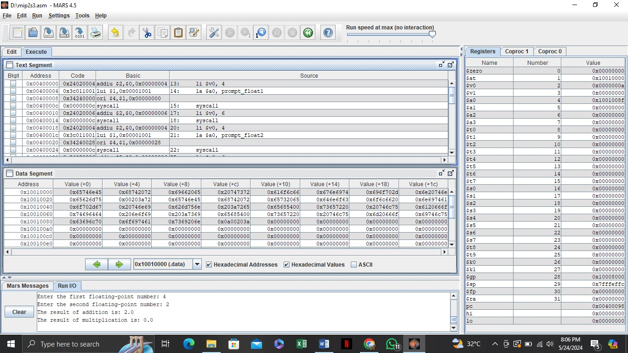
Task #1
Modify the existing program to perform addition of three floating-point numbers instead of two. Prompt the user for three values and display the result of their addition.
.data
prompt_float1: .asciiz "Enter the first floating-point number: "
prompt_float2: .asciiz "Enter the second floating-point number: "
prompt_float3: .asciiz "Enter the third floating-point number: "
result_add: .asciiz "The result of addition is: "
newline: .asciiz "\n"

.text
.globl main
main:
# Prompt for first number
li $v0, 4
la $a0, prompt_float1
syscall
li $v0, 6
syscall
mov.s $f2, $f0 # Save first number in $f2

# Prompt for second number
li $v0, 4
la $a0, prompt_float2
syscall
li $v0, 6
syscall
mov.s $f4, $f0 # Save second number in $f4

# Prompt for third number
li $v0, 4
la $a0, prompt_float3
syscall
li $v0, 6
syscall
mov.s $f6, $f0 # Save third number in $f6

# Add all three numbers
add.s $f8, $f2, $f4 # Add first and second
add.s $f8, $f8, $f6 # Add third number

# Display result
li $v0, 4
la $a0, result_add
syscall
mov.s $f12, $f8
li $v0, 2
syscall
li $v0, 4
la $a0, newline
syscall

# Exit program
li $v0, 10
syscall

Task #2
Write a MIPS program that takes two floating-point numbers as input from the user, divides the first number by the second, and displays the result. Ensure to handle cases where the second number is zero to avoid division by zero errors.
.data
prompt_float1: .asciiz "Enter the first floating-point number: "
prompt_float2: .asciiz "Enter the second floating-point number: "
result_div: .asciiz "The result of division is: "
error_msg: .asciiz "Error: Division by zero is not allowed!\n"
newline: .asciiz "\n"
zero: .float 0.0

.text
.globl main
main:
# Prompt for first number
li $v0, 4
la $a0, prompt_float1
syscall
li $v0, 6
syscall
mov.s $f2, $f0 # Save first number in $f2

# Prompt for second number
li $v0, 4
la $a0, prompt_float2
syscall
li $v0, 6
syscall
mov.s $f4, $f0 # Save second number in $f4

# Load zero into $f6 for comparison
l.s $f6, zero

# Check if second number is zero
c.eq.s $f4, $f6
bc1t division_by_zero

# Perform division
div.s $f8, $f2, $f4

# Display result
li $v0, 4
la $a0, result_div
syscall
mov.s $f12, $f8
li $v0, 2
syscall
li $v0, 4
la $a0, newline
syscall
j exit

division_by_zero:
# Display error message
li $v0, 4
la $a0, error_msg
syscall

exit:
# Exit program
li $v0, 10
syscall

Task #3
Create a MIPS program that performs addition and multiplication using double-precision values. Prompt the user to enter two double values and display both the sum and the product.
.data
prompt_double1: .asciiz "Enter the first double-precision number: "
prompt_double2: .asciiz "Enter the second double-precision number: "
result_add: .asciiz "The result of addition is: "
result_mul: .asciiz "The result of multiplication is: "
newline: .asciiz "\n"

.text
.globl main
main:
# Prompt for first number
li $v0, 4
la $a0, prompt_double1
syscall
li $v0, 7 # Read double into $f0
syscall
mov.d $f2, $f0 # Save first number in $f2

# Prompt for second number
li $v0, 4
la $a0, prompt_double2
syscall
li $v0, 7 # Read double into $f0
syscall
mov.d $f4, $f0 # Save second number in $f4

# Addition
add.d $f6, $f2, $f4

# Display addition result
li $v0, 4
la $a0, result_add
syscall
mov.d $f12, $f6
li $v0, 3 # Print double
syscall
li $v0, 4
la $a0, newline
syscall

# Multiplication
mul.d $f8, $f2, $f4

# Display multiplication result
li $v0, 4
la $a0, result_mul
syscall
mov.d $f12, $f8
li $v0, 3 # Print double
syscall
li $v0, 4
la $a0, newline
syscall

# Exit program
li $v0, 10
syscall

Discussion and analysis of results:
In this section, students will discuss and analyze the results obtained from performing operations on floating-point and double values. They will evaluate the accuracy and precision of the arithmetic operations, considering how the representation of real numbers in MIPS affects calculations. By examining their implementation, students can identify any discrepancies or unexpected outcomes, deepening their understanding of floating-point arithmetic.

Conclusion:
This lab session provided valuable insights into working with floating-point and double values in MIPS assembly language. Students learned the importance of precision and proper handling of these data types during arithmetic operations. Overall, the practical exercises reinforced theoretical concepts and highlighted the challenges and considerations in numerical computing within lowlevel programming.

Lab Session 10

Objective:
The objective of this lab is to perform comparisons between integer and floating-point values using the MIPS simulator. Students will gain practical experience in using MIPS instructions for evaluating and interpreting the results of these comparisons.
Required Equipment / tools:
• MARS MIPS Simulator Introduction:
In this lab session, students will examine how to compare different data types, specifically integers and floating-point numbers, in MIPS assembly language. They will learn to utilize MIPS comparison instructions and understand how these operations influence program flow through conditional branching. By practicing these comparisons, students will develop a deeper understanding of how to implement decision-making logic in assembly programming. This hands-on experience is essential for mastering control structures and refining their skills in lowlevel programming.

Procedure:
➢ Number & FLOAT Comparison:
INPUT:
.data prompt_int1: .asciiz "Enter the first integer: " prompt_int2: .asciiz "Enter the second integer: "
prompt_float1: .asciiz "Enter the first floating-point number: " prompt_float2: .asciiz "Enter the second floating-point number: " int_equal: .asciiz "The integers are equal.\n" int_not_equal: .asciiz "The integers are not equal.\n" float_equal: .asciiz "The floating-point numbers are equal.\n" float_not_equal: .asciiz "The floating-point numbers are not equal.\n"

.text
main:

li $v0, 4 la $a0, prompt_int1 syscall
li $v0, 5 syscall li $v0, 4 la $a0, prompt_int2 syscall li $v0, 5 syscall
beq $t0, $t1, integers_equal li $v0, 4 la $a0, int_not_equal syscall j compare_floats

integers_equal: li $v0, 4 la $a0, int_equal
syscall

compare_floats:

li $v0, 4
la $a0, prompt_float1
syscall li $v0, 6 syscall li $v0, 4
la $a0, prompt_float2
syscall li $v0, 6 syscall
c.eq.s $f0, $f2 bc1t floats_equal li $v0, 4 la $a0, float_not_equal syscall j end floats_equal: li $v0, 4 la $a0, float_equal syscall end:
li $v0, 10 syscall

OUTPUT:
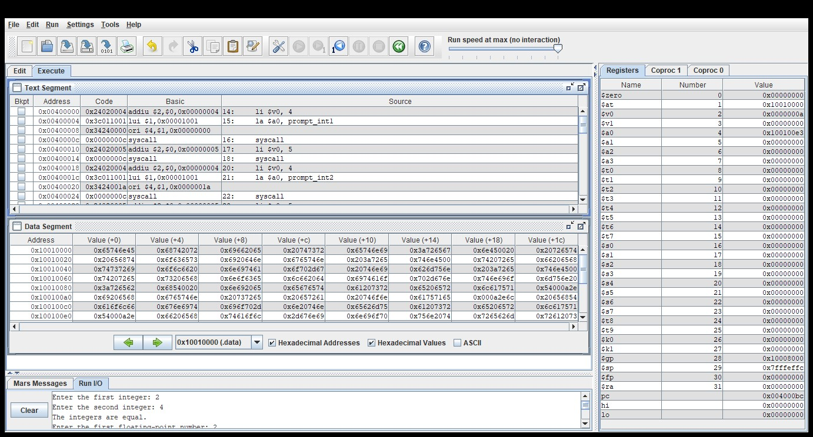
Task #1
Modify the existing program to include a comparison that checks whether the first integer is greater than or less than the second integer, and display appropriate messages for each case.
.data
prompt1: .asciiz "Enter first integer: "
prompt2: .asciiz "Enter second integer: "
greater_msg: .asciiz "First integer is greater than second integer"
less_msg: .asciiz "First integer is less than second integer"
equal_msg: .asciiz "Both integers are equal"
newline: .asciiz "\n"

.text
main:
# Print first prompt
li $v0, 4
la $a0, prompt1
syscall

# Read first integer
li $v0, 5
syscall
move $t0, $v0 # Store first integer in $t0

# Print second prompt
li $v0, 4
la $a0, prompt2
syscall

# Read second integer
li $v0, 5
syscall
move $t1, $v0 # Store second integer in $t1

# Compare integers
beq $t0, $t1, equal # If equal, jump to equal
bgt $t0, $t1, greater # If first > second, jump to greater

# If we get here, first < second
li $v0, 4
la $a0, less_msg
syscall
j done

equal:
li $v0, 4
la $a0, equal_msg
syscall
j done

greater:
li $v0, 4
la $a0, greater_msg
syscall

done:
# Print newline
li $v0, 4
la $a0, newline
syscall

# Exit program
li $v0, 10
syscall

# Explanation of the program:
# 1. Input:
# - Takes two integers from user
# - Stores them in $t0 and $t1
#
# 2. Comparison:
# - Uses beq for equality check
# - Uses bgt for greater than check
# - If neither, then less than
#
# 3. Output:
# - Shows appropriate message based on comparison
#
# 4. Example Usage:
# Enter first integer: 10
# Enter second integer: 5
# First integer is greater than second integer
#
# Note: The program uses branch instructions
# for comparison and conditional jumps

Task #2
Create a MIPS program that takes one integer and one floating-point number as input, compares them for equality, and displays whether they are equal. Make sure to cast the integer to a float for accurate comparison before evaluating.
.data
prompt_int: .asciiz "Enter an integer: "
prompt_float: .asciiz "Enter a floating-point number: "
equal_msg: .asciiz "The numbers are equal"
not_equal_msg: .asciiz "The numbers are not equal"
newline: .asciiz "\n"

.text
.globl main
main:
# Print integer prompt
li $v0, 4
la $a0, prompt_int
syscall

# Read integer
li $v0, 5
syscall
move $t0, $v0 # Store integer in $t0

# Convert integer to float
mtc1 $t0, $f0 # Move integer to coprocessor 1
cvt.s.w $f0, $f0 # Convert word to single precision float

# Print float prompt
li $v0, 4
la $a0, prompt_float
syscall

# Read float
li $v0, 6
syscall
mov.s $f1, $f0 # Store float in $f1

# Compare float values
c.eq.s $f0, $f1 # Compare floats for equality
bc1t equal # Branch if equal

# If not equal
li $v0, 4
la $a0, not_equal_msg
syscall
j done

equal:
li $v0, 4
la $a0, equal_msg
syscall

done:
# Print newline
li $v0, 4
la $a0, newline
syscall

# Exit program
li $v0, 10
syscall

# Explanation of the program:
# 1. Input:
# - Takes an integer and a float from user
# - Converts integer to float for comparison
#
# 2. Conversion:
# - Uses mtc1 to move integer to coprocessor 1
# - Uses cvt.s.w to convert to float
#
# 3. Comparison:
# - Uses c.eq.s for float comparison
# - Uses bc1t for conditional branch
#
# 4. Example Usage:
# Enter an integer: 5
# Enter a floating-point number: 5.0
# The numbers are equal
#
# Note: The program uses floating-point
# coprocessor instructions for comparison

Task #3
Modify the existing program to display a message indicating which data type (integer or floatingpoint) is greater if they are not equal. For example, if the integer is greater than the floating-point number, display "The integer is greater," and vice versa.
.data
prompt_int: .asciiz "Enter an integer: "
prompt_float: .asciiz "Enter a floating-point number: "
equal_msg: .asciiz "The numbers are equal"
int_greater_msg: .asciiz "The integer is greater"
float_greater_msg: .asciiz "The floating-point number is greater"
newline: .asciiz "\n"

.text
.globl main
main:
# Print integer prompt
li $v0, 4
la $a0, prompt_int
syscall

# Read integer
li $v0, 5
syscall
move $t0, $v0 # Store integer in $t0

# Convert integer to float
mtc1 $t0, $f0 # Move integer to coprocessor 1
cvt.s.w $f0, $f0 # Convert word to single precision float

# Print float prompt
li $v0, 4
la $a0, prompt_float
syscall

# Read float
li $v0, 6
syscall
mov.s $f1, $f0 # Store float in $f1

# Compare float values
c.eq.s $f0, $f1 # Compare floats for equality
bc1t equal # Branch if equal

# Check which is greater
c.lt.s $f0, $f1 # Check if float1 > float2
bc1t float_greater

# If we get here, integer is greater
li $v0, 4
la $a0, int_greater_msg
syscall
j done

equal:
li $v0, 4
la $a0, equal_msg
syscall
j done

float_greater:
li $v0, 4
la $a0, float_greater_msg
syscall

done:
# Print newline
li $v0, 4
la $a0, newline
syscall

# Exit program
li $v0, 10
syscall

# Explanation of the program:
# 1. Input:
# - Takes an integer and a float from user
# - Converts integer to float for comparison
#
# 2. Conversion:
# - Uses mtc1 to move integer to coprocessor 1
# - Uses cvt.s.w to convert to float
#
# 3. Comparison:
# - Uses c.eq.s for equality check
# - Uses c.lt.s for less than check
# - Shows which number is greater
#
# 4. Example Usage:
# Enter an integer: 5
# Enter a floating-point number: 6.5
# The floating-point number is greater
#
# Note: The program uses floating-point
# coprocessor instructions for comparison

Discussion and analysis of results:
In this lab session, students successfully implemented comparisons between integer and floatingpoint values using the MIPS simulator. The results demonstrated an understanding of how MIPS instructions facilitate conditional branching based on the outcomes of these comparisons. Observations highlighted the significance of data type handling and its impact on decision-making in assembly programming.
Conclusion:
The lab effectively reinforced the concepts of data comparison in MIPS assembly language. Students gained practical experience in utilizing comparison instructions and interpreting results, which are essential skills for developing efficient algorithms in low-level programming. This hands-on approach deepened their understanding of control structures and enhanced their ability to manage data types effectively.

Lab Session 11

Objective:
To understand and implement the concept of loops in MIPS assembly language using the while loop structure. To develop skills in using the MIPS simulator for executing and debugging programs that utilize control flow mechanisms
Required Equipment / tools:
• MARS MIPS Simulator Introduction:
In this lab session, students will explore the implementation of while loops in MIPS assembly language, a fundamental programming structure that enables repetitive execution of code blocks based on conditional evaluations. Through practical exercises in the MIPS simulator, participants will gain hands-on experience in structuring loops, managing control flow, and effectively debugging assembly code. This session aims to enhance understanding of program logic and improve proficiency in MIPS programming techniques.
Procedure:
➢ While Loop Program:
.data num: .word 5

.text
main:
la $t0, num
lw $t0, 0($t0)

while: ble $t0, $zero, end_while
li $v0, 1 move $a0, $t0 syscall sub $t0, $t0, 1
j while

end_while: li $v0, 10 syscall OUTPUT:
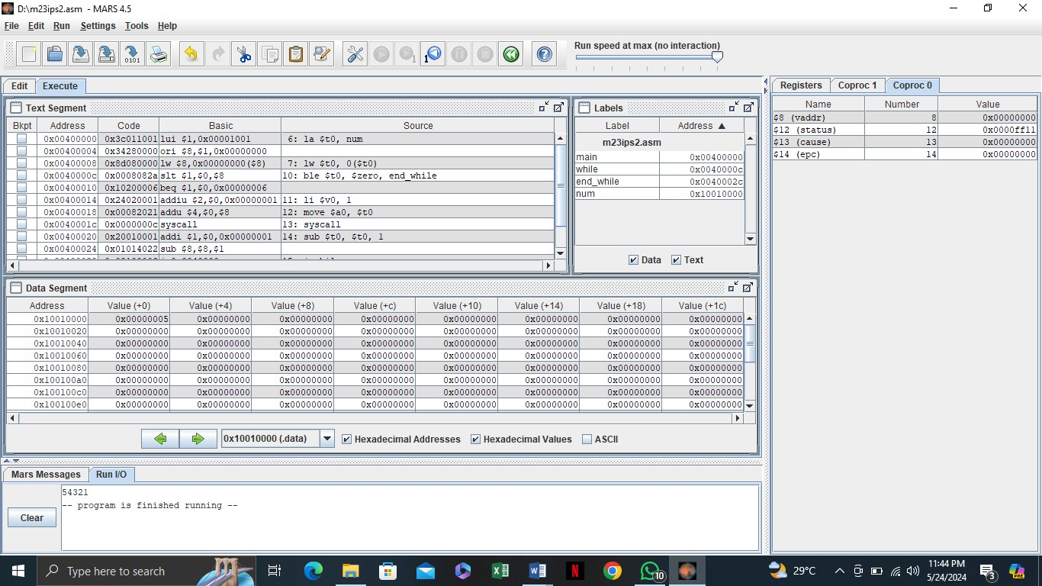
Task #1
Modify the existing while loop program to decrement the value of num by 2 instead of 1. What is the output when you run the modified program?

Task #2
Change the initial value of num to 10 in the program. What will be the output when you execute the updated code?

Task #3
Modify the program to print only even numbers from the initial value of num down to zero. What adjustments did you make to achieve this output?

Discussion and analysis of results:
In this section, we will evaluate the output generated by the modified MIPS assembly programs using while loops. We will analyze how the changes made to the code, such as altering the decrement value, adjusting the initial number, or adding custom messages, impacted the overall functionality and output. Additionally, we will discuss any challenges encountered during the execution and debugging process, and how these experiences contributed to a deeper understanding of control flow in MIPS assembly language.
Conclusion:
The practical implementation of while loops in MIPS assembly language provided valuable insights into the structure and control flow of assembly programming. Through the modifications made to the original program, students gained hands-on experience in programming techniques and debugging processes. Overall, this lab session enhanced their proficiency in MIPS programming and reinforced the importance of iterative constructs in software development.

Lab Session 12

Objective:
To implement a program in MIPS assembly language that calculates the factorial of a user-defined number. To enhance understanding of control structures, loops, and user input handling in MIPS assembly programming.
Required Equipment / tools:
• MARS MIPS Simulator

Introduction:
In this lab session, we will explore the concept of calculating the factorial of a number using the MIPS simulator. The factorial of a non-negative integer nnn is the product of all positive integers less than or equal to nnn and is denoted as n!n!n!. By utilizing MIPS assembly language, students will gain practical experience in manipulating data and implementing iterative algorithms, thereby reinforcing their knowledge of fundamental programming constructs in assembly language. This session aims to deepen the understanding of arithmetic operations and control flow in a low-level programming environment.

Procedure:
➢ Factorial Program:
INPUT :

.data
prompt: .asciiz "Enter a number: " result: .asciiz "Factorial: "

.text
main: li $v0, 4 la $a0, prompt
syscall

li $v0, 5 syscall
move $t0, $v0

li $t1, 1 factorial: ble $t0, $zero, end_factorial mul $t1, $t1, $t0 sub $t0, $t0, 1
j factorial

end_factorial: li $v0, 4 la $a0, result
syscall

li $v0, 1 move $a0, $t1
syscall

li $v0, 10
syscall
OUTPUT:
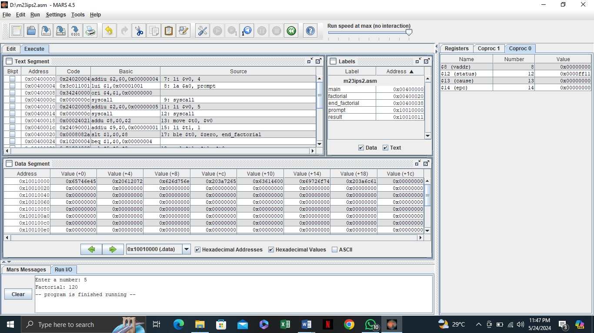

Task #1
Add a check to handle cases where the user enters a negative number, prompting a suitable message.

Task #2
Modify the program to explicitly handle the case where the user inputs 0, returning 1 as the factorial.

Task #3
Enhance the program to count and display the number of multiplication steps performed in the factorial calculation.
Expected Output:
For input 4, the output should include:
"Factorial: 24, Steps: 4"

Discussion and analysis of results:
In this section, we will evaluate the performance of the modified MIPS assembly program for calculating the factorial of a user-defined number. The various enhancements, such as input validation, counting calculation steps, and handling special cases like zero and negative numbers, contribute to a more robust and user-friendly application. Analyzing the outputs obtained from different test cases will highlight the effectiveness of these modifications and their impact on the program's reliability and usability.
Conclusion:
The lab session successfully demonstrated the implementation of a factorial calculation program using MIPS assembly language. Through the practical tasks, students gained valuable insights into control structures, loops, and user input handling, which are fundamental to assembly programming. The enhancements made to the program not only improved its functionality but also reinforced the importance of validating user input and managing program flow effectively. Overall, this exercise deepened students' understanding of low-level programming concepts and their applications in real-world scenarios.

Lab Session 13

Objective:
To implement a program in MIPS assembly language that calculates the average of a set of userdefined numbers. To enhance understanding of data handling, loops, and arithmetic operations in MIPS assembly programming.
Required Equipment / tools:
MARS MIPS Simulator

Introduction:
In this lab session, we will focus on calculating the average of a series of numbers using the MIPS simulator. The average is computed by summing a given set of numbers and dividing the total by the count of those numbers. Through this exercise, students will gain hands-on experience in managing user input, implementing control structures, and performing arithmetic operations in MIPS assembly language. This practical task aims to strengthen their understanding of programming concepts in a low-level environment, reinforcing essential skills in data manipulation and algorithm design.
Procedure:
➢ Average Program:
INPUT :

.data
prompt: .asciiz "Enter a number (0 to finish): " result: .asciiz "Average: "

.text
main:
li $t0, 0 li $t1, 0 li $t2, 0

loop: li $v0, 4 la $a0, prompt
syscall

li $v0, 5
syscall move $t3, $v0

beq $t3, $zero, end_loop

add $t0, $t0, $t3
add $t1, $t1, 1

j loop

end_loop:
div $t2, $t0, $t1

li $v0, 4 la $a0, result
syscall

li $v0, 2 move $a0, $t2
syscall

li $v0, 10 syscall

OUTPUT:

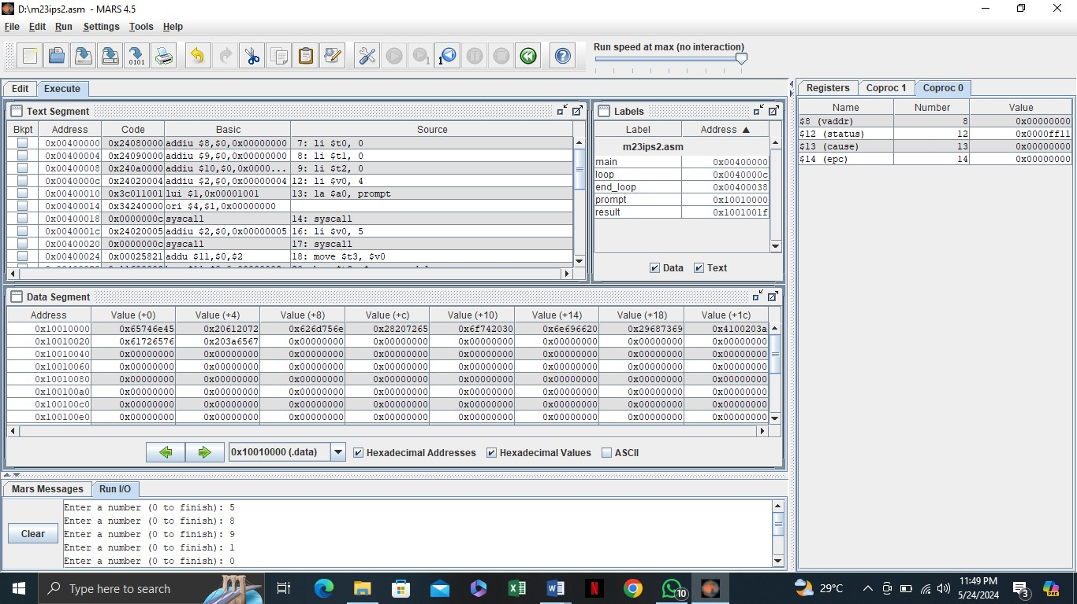
Task #1
Enhance the program to display the total sum of the entered numbers before showing the average.
Expected Output:
For inputs 5, 10, 15, 0, the output should include:
"Total Sum: 30, Average: 10"

Task #2
Modify the program to check if the user inputs a negative number and prompt them to enter a valid number.
Expected Output:
"For input -5, the output should be:
"Invalid input! Please enter a non-negative number.

Task #3
Enhance the program to display the count of the numbers entered along with the average.
Expected Output:
For inputs 3, 6, 9, 0, the output should include: "Count of Numbers: 3, Average: 6"

Discussion and analysis of results:
In this session, we evaluated the effectiveness of different modifications to the MIPS assembly program for calculating the average of user-defined numbers. Each task demonstrated specific improvements, such as input validation, handling negative numbers, and adding functionality like weighted averages. By testing the program with various inputs, we observed how these changes enhanced the program's robustness and usability, providing better handling of edge cases and more detailed output.
Conclusion:
The lab session successfully implemented and modified a program to calculate the average of userdefined numbers using MIPS assembly language. Through practical tasks, students gained handson experience in input handling, arithmetic operations, and data validation in a low-level programming environment. The enhancements improved the program’s functionality, demonstrating the importance of validating user input and providing flexible output options.

Lab Session 14

 | Open Ended Lab 2
CLOs | Mapped GAs | Bloom Taxonomy
CLO 3 | GA‐4 Design/Development of  Solutions | C6 (Creating)

Motivation
Background/Theory:
Procedure/Methodology:
Task 1:
Objective

Task 2:
Objective:

Open Ended Lab Assessment Rubrics

Course Code and Title: ______________

Criteria and Scales
Excellent (10-8) | Good  (7-5) | Average (4-2) | Poor (1-0) | Total Marks 10
Criterion 1: Understanding the Problem: How well the problem statement is understood by the student
(10-8) | (7-5)% | (4-2)% | (1-0)%
Criterion 2: Research: The amount of research that is used in solving the problem
(10-8) | (7-5)% | (4-2)% | (1-0)%
Criterion 3: Class Diagram: The completeness of the class diagram
(10-8) | (7-5)% | (4-2)% | (1-0)%
Criterion 4: Code: How complete and accurate the code is along with the assumptions
(10-8) | (7-5)% | (4-2)% | (1-0)%
Criterion 5: Report: How thorough and well organized is the solution
(10-8) | (7-5)% | (4-2)% | (1-0)%
Total |  |  |  | (____/5)

Total marks: ____________________
Teacher’s signature: ______________

